5.89: The upward friction force must be 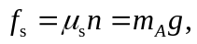 and the normal force, which is the only horizontal force on block A, must be 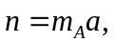 and so 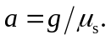 An observer on the cart would “feel” a backwards force, and would say that a similar force acts on the block, thereby creating the need for a normal force.

